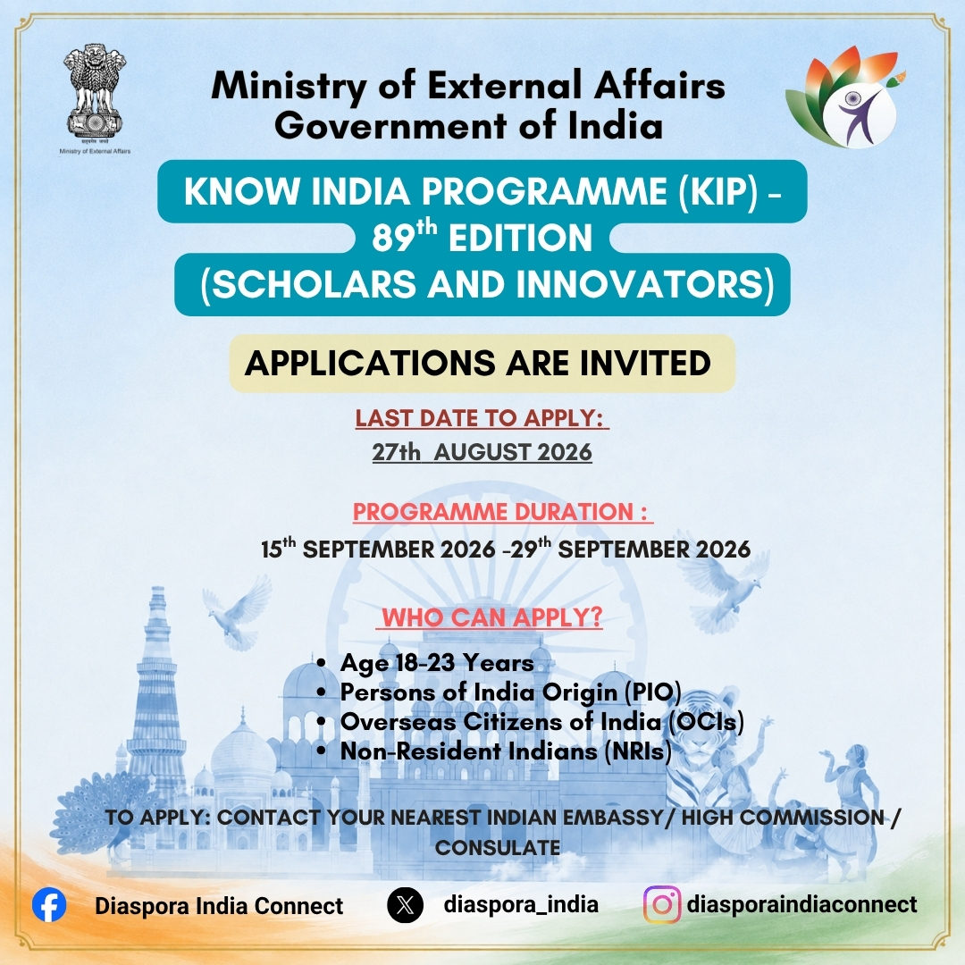

Know India Programme (KIP) for the Cohort of 'Scholars and Innovators'

Important Points for Applicants to Keep in Mind While Applying
Age eligibility: Applicant must be 18–23 years of age, with eligibility determined as on 1st August 2026.
Indian origin/status: Applicant must be a youth of Indian origin and should qualify as a PIO, OCI or NRI, as applicable.
Proof of Indian origin/status:
    - PIO/OCI applicants should provide their OCI/PIO Card number, or that of their parent(s)/grandparent(s), as applicable.
    - NRI applicants must provide appropriate proof of Indian citizenship/residency abroad establishing NRI status.
Educational qualification:
Applicant must have completed 12th Class/school graduation from an educational institution recognized by the host country/government.
English proficiency: Applicant must be proficient in spoken English and must either:
    - have studied English as a subject at high-school level; or
    - have completed undergraduate education with English as the medium of instruction.
Previous participation: Applicant must not have previously participated in KIP or in any other programme organized and funded by the Ministry of External Affairs, another Ministry/Department of the Government of India, or a State Government in India.
Programme duration: The programme will be held from 15–29 September 2026, for approximately two weeks including travel time.
Programme participation: Selected applicants must be available to participate in the entire programme, including travel, institutional visits, cultural activities, state/UT visits and other scheduled activities.
International travel and medical insurance: Selected participants must obtain and submit a valid comprehensive international travel and medical insurance policy covering the entire duration of their stay in India.
Medical fitness: Selected participants will be required to submit a medical fitness certificate/report from a recognized doctor, confirming their ability to undertake long/extended-duration travel.
Airfare contribution: Government of India will bear 90% of the airfare, while the participant will bear the remaining 10%.
Non-completion of programme: The participant will be required to sign an undertaking that, in case they do not complete the KIP, they will reimburse the Embassy of India, Vilnius the amount of airfare borne by the Government of India, as applicable.
Accommodation and local transport: Boarding/lodging in designated hotels and internal transportation in India, including airport transfers, will be provided as per KIP arrangements.
Visa: Gratis visa will be issued by the concerned Embassy of India, Vilnius to selected participants, subject to submission of all required documents and fulfilment of applicable requirements.
Documents must be genuine and complete: Applicants should ensure that all information and supporting documents submitted with the application are accurate, complete, valid and verifiable.
Passport: Applicant should possess a valid passport and submit a clear copy as part of the application.
Photograph: A recent passport-size colour photograph must be submitted.
Programme report: Successful participants must submit a 750–1000-word Programme Report describing their experiences, key learnings and understanding of contemporary India and its cultural heritage.
Certificate: Certificate of Participation will be awarded upon successful completion of the programme.
Selection is not automatic: Submission of an application does not guarantee selection. Final selection will be made by the Ministry of External Affairs from candidates recommended by Indian Missions/Posts.
Availability: Applicants should apply only if they are able to make themselves available for the complete programme period and comply with pre-departure requirements within the stipulated timelines.
Application deadline: Applications must be submitted in person by 27 August 2026 at the Embassy of India, located on the 4th and 5th floors at Gedimino pr. 12, 01102 Vilnius, Lithuania.
Late/incomplete applications will not be considered

